**ASSIGNMENT 14.1**

PROBLEM STATEMENT

Create a calculator to work with rational numbers.

Requirements:

○ It should provide capability to add, subtract, divide and multiply rational numbers

○ Create a method to compute GCD (this will come in handy during operations on rational)

Solutions:

Step 1:

Execute the calculator using scala with the help of class and objects.

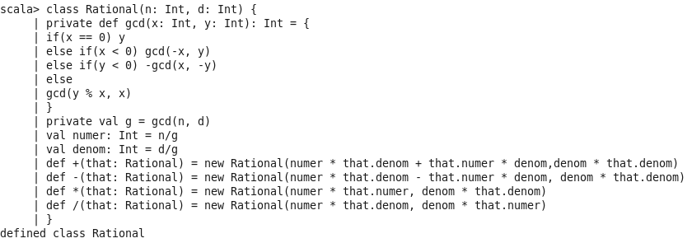

Step 2:

Output of the program:

